NumPy for Artificial Intelligence mini project
Code ouput:
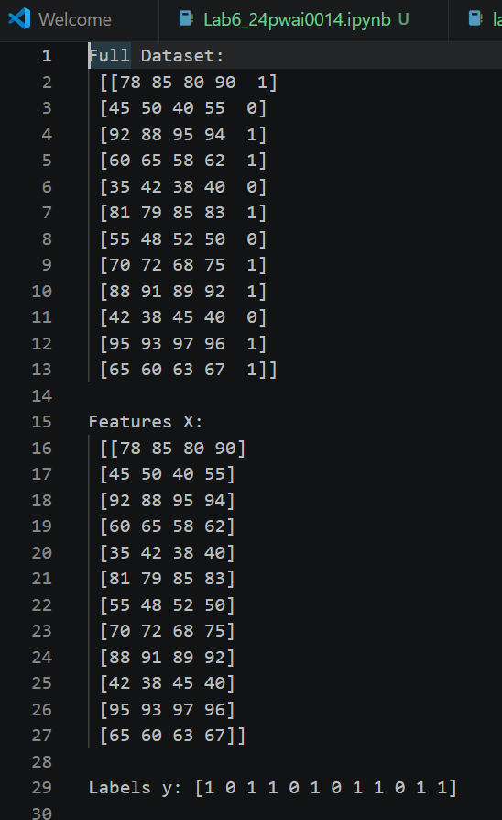
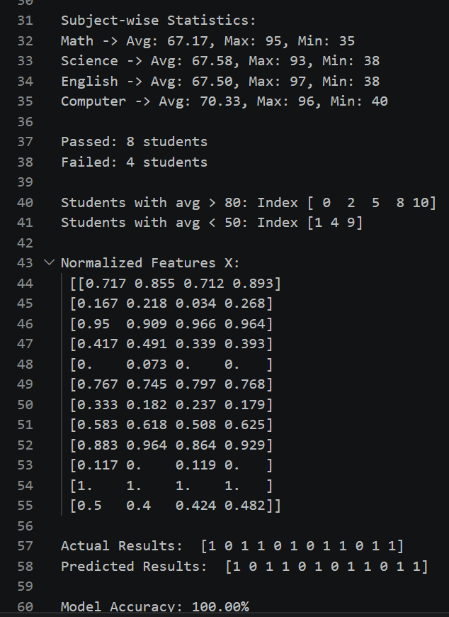

Learning outcome:
1. Data Handling with NumPy: NumPy arrays make it easy to store and slice tabular data. Using `data[:, :4]` to separate features and labels is much faster than Python lists.

2. Vectorized Operations: Functions like `np.mean`, `np.max`, `np.sum` with `axis=0` or `axis=1` let us do column-wise or row-wise math without loops. This is key for AI because real datasets have millions of rows.

3. Preprocessing: Normalization using `(X - min)/(max - min)` scales all features to 0-1. This prevents subjects with higher marks from dominating the model. It's a standard step before training ML models.

4. Basic Prediction Logic: We built a rule-based "AI" that predicts pass/fail if avg >= 60. Real AI models learn these rules from data, but the NumPy mechanics are the same.

5. Model Evaluation: Comparing `predictions == y` and taking the mean gives accuracy. This shows how well our simple logic matches actual results.

